**Project 3 Proposal:   
*New Zealand Earthquake Visualisation.***

**Group 1 Team Members:**

* Barsha Basel
* Hiew N Doan (Vincent)
* Micah Raquena-Pequeno
* Richard Thornton
* Roberto Sammassimo

**Topic:**

New Zealand is one of the hotspots for earthquake activity in the world. The Geonet site from New Zealand provides local earthquake datasets.

We will be using this data to create a dashboard to visualise New Zealand earthquake activity over the last 365 days including a dynamic summary of data with a map of locality and magnitude.

The purpose of our dashboard will be to explore daily experience of earthquake activity and identify occurrences of severe events in areas of greater risk.

**Data:**

* [GeoNet: Home](https://www.geonet.org.nz/)

* [Earthquakes Data NZ | Kaggle](https://www.kaggle.com/datasets/kkhandekar/earthquakes-data-nz)

**Drawing inspiration:**

Figure 1

Temblor Heatmap identifying shaking forecast, Faultline & Earthquake.

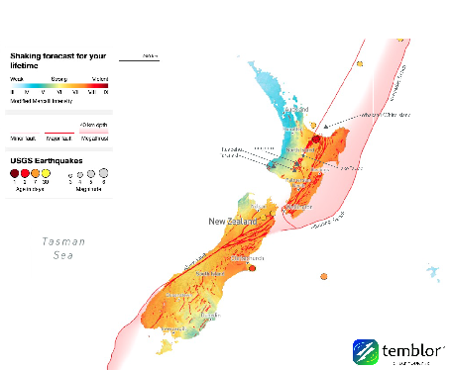

Figure 2

Geonet map identifying key earthquake location.

Figure 3

Global earthquake dashboard including summary and key event.

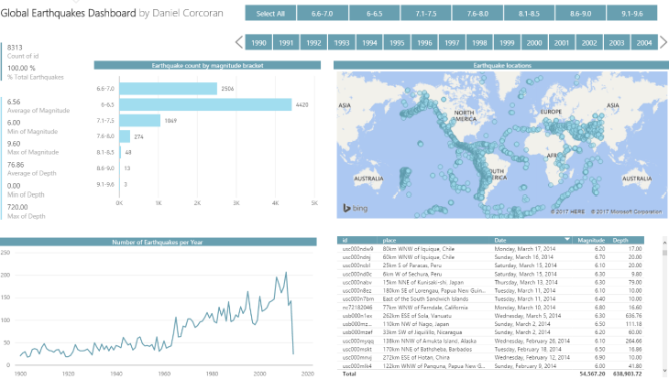

**Final Sketch:**

Below shows the proposed layout.

**GITHUB Respository:**  
[micah-trp/Project-3-Visualisation-Group-1: Project 3 - Visualisation (github.com)](https://github.com/micah-trp/Project-3-Visualisation-Group-1)

**Image Resources:**

* Figure 1: [New Zealand earthquake causes tiny tsunami - Temblor.net](https://temblor.net/earthquake-insights/new-zealand-earthquake-causes-tiny-tsunami-1300/)
* Figure 2: [GeoNet: DART Network](https://www.geonet.org/)
* Figure 3: [POWER BI – GLOBAL EARTHQUAKES (1900-2014) DASHBOARD – Daniels Coding Blog (wordpress.com)](https://danielcorcoranssql.wordpress.com/2017/04/07/power-bi-global-earthquakes-1900-2014-dashboard/)